Roosc Zaño

Day 2
Student Enrollment Web API – Console App to Full CRUD + Postman
Part 3 – API: Write Operations
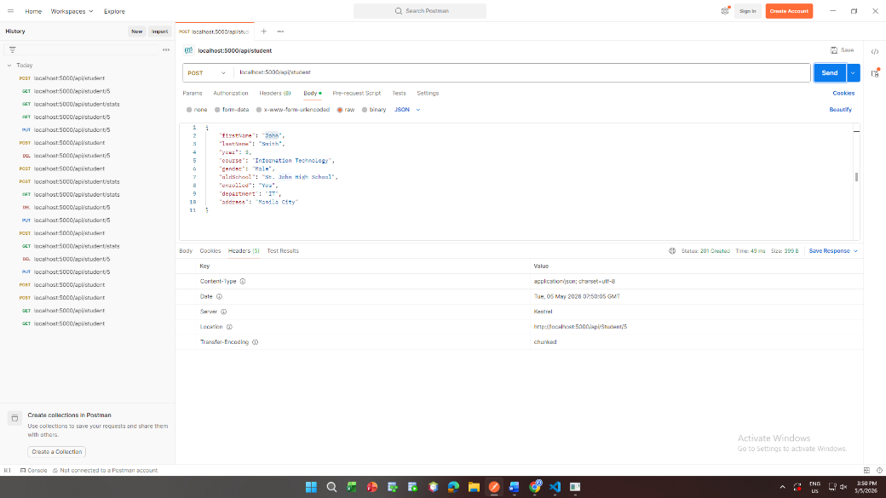
POST /api/student

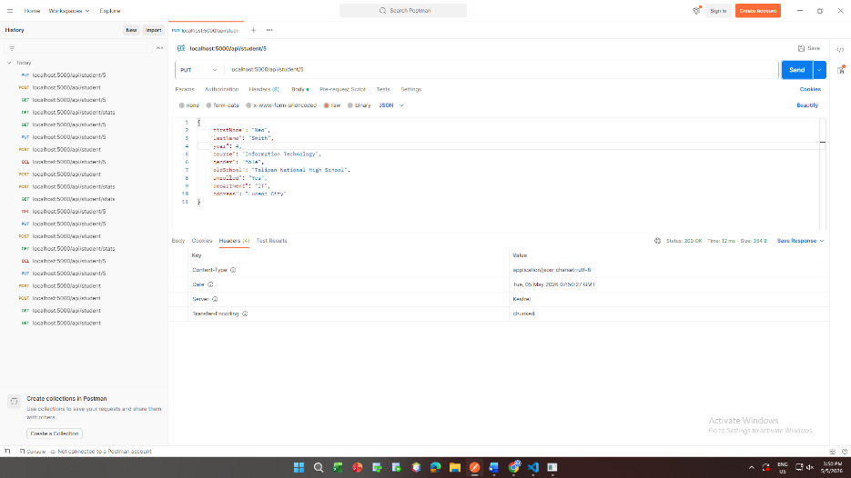
PUT /api/student/5

PATCH /api/student/5
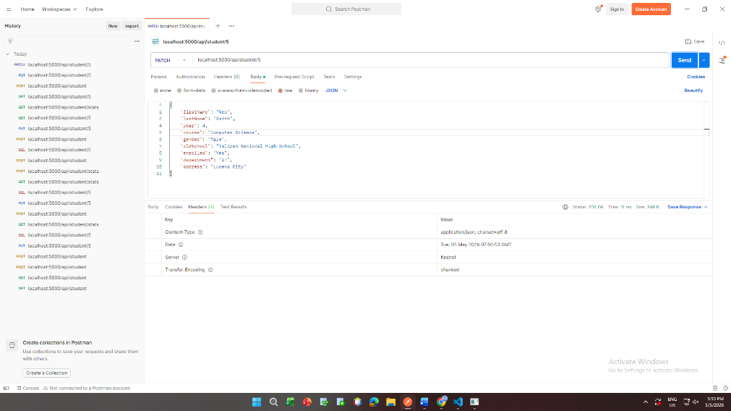
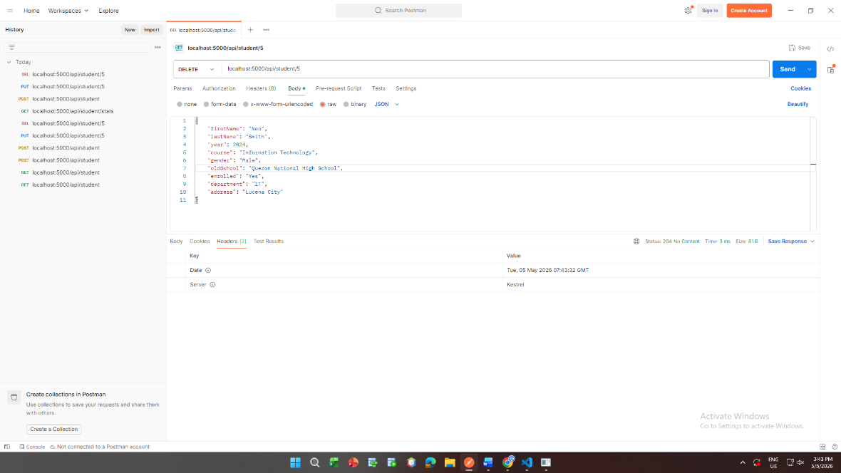
DELETE /api/student/5

Part 4 – Polish & Collections
GET /api/student/stats
